PRESS RELEASE
PRESS CONTACT:
For downloadable graphics, please go to:
CharityTour.org/html/media.html
Lisa Liebl
405.623.0023
lisa@mega-media.biz
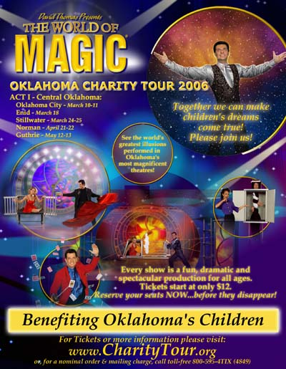
A Statewide Tour is Set to Make Magic for Children’s Charities
(Oklahoma City, OK— February 16, 2006) – There is something magical about charity — just one reason The World of Magic Oklahoma Charity Tour is bringing the world's greatest illusions in a major theatrical production to venues across Oklahoma.
“Through this fantasy world of magic we are sharing our spirit for other people with a special focus on children,” said Jim Ratchford, President of Camille Productions and manager of the Charity Tour. “We know that whenever any of us meet the needs or lift the spirits of another—especially a child—something magical happens.”
Throughout 2006, the Oklahoma Charity Tour will be bringing The World of Magic to adults, children and communities throughout Oklahoma. The tour magically appears first in the Oklahoma City/Edmond area on March 10th in the Hardeman Auditorium at Oklahoma Christian University. The tour then moves to Enid on March 18, followed by Stillwater, Norman and Guthrie.
The World of Magic Oklahoma Charity Tour will benefit statewide and local charities in each community. Charities supported by the tour include Big Brothers Big Sisters, Children’s Miracle Network, The Christmas Connection, Make-A-Wish Foundation, Oklahoma Brain Tumor Foundation, Safe Kids, YWCA and more.
The World of Magic includes electrifying feats of magic, beautiful dancers in lavish costumes and captivating audience participation elements. The World of Magic is produced by Master Illusionist David Thomas, whose work was recognized with an Emmy Award for special event production in 2003. He was also honored as Entertainer of the Year in 2004 by Event Solutions Magazine, the leading information source for the special events industry. As the producer for elaborate magical and theatrical productions for places like Six Flags Theme Parks, Las Vegas, Branson and special events around the globe, David Thomas puts his magic touch on thousands of live performances every year.
American Entertainment Magazine, in their recent nomination of David Thomas for their Entertainer of the Year and Best Novelty Act awards for 2006, said "David performs at Fortune 500 events and shares the spotlight with America’s most respected celebrities and dignitaries. As executive producer of elaborate magical productions, David’s talents resound from showrooms to vacation destinations globally. David Thomas displays an extensive entertainment range and defines “The World of Magic.”
Tickets for The World of Magic Charity Tour are $14-$60 for adults and $12 for kids. Sponsorships are also available. For more information or tickets call (800) 595-4849 or visit www.charitytour.org.
###

