PRESS RELEASE
PRESS CONTACT:
For downloadable graphics, please go to:
CharityTour.org/html/media.html
Lisa Liebl
405.623.0023
lisa@mega-media.biz
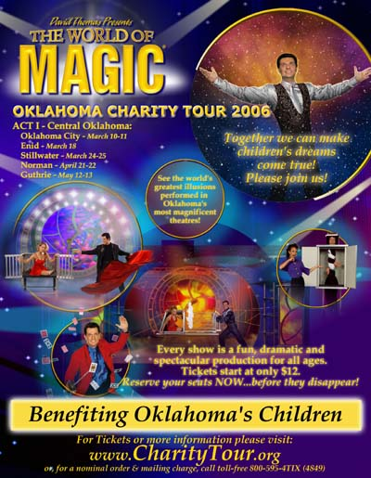
Master Illusionist will Magically Appear at Elementary School
(Oklahoma City, OK— February 28, 2006) – The World of Magic Oklahoma Charity Tour is giving a sneak preview to the students at Johnson Elementary School, 1810 Sheffield, OKC, Thursday, March 2, at 2:00pm.
The World of Magic Oklahoma Charity Tour is the world's greatest illusions in a major theatrical production. It is produced by Master Illusionist David Thomas. As the producer for elaborate magical and theatrical productions for places like Six Flags Theme Parks, Las Vegas, Branson and special events around the globe, Thomas puts his magic touch on thousands of live performances every year.
With the assistance of the Oklahoma City Public Schools Foundation, every elementary student of the Oklahoma City Public School District is receiving a free pass. The passes may be redeemed at a special Oklahoma City School Night show in Hardeman Auditorium at Oklahoma Christian University on Thursday evening, March 9 or to any other show of the Oklahoma Charity Tour 2006.
The World of Magic Oklahoma Charity Tour will benefit statewide and local charities in each community. Charities supported by the tour include Big Brothers Big Sisters, Children’s Miracle Network, The Christmas Connection, Make-A-Wish Foundation, Oklahoma Brain Tumor Foundation, Ronald McDonald House Charities, Safe Kids, YWCA and more.
Tickets for The World of Magic Charity Tour are $14-$60 for adults and $12 for kids. For more information or tickets call (800) 595-4849 or visit www.charitytour.org.
###

